**TASK 4:**

### 1. Write an SQL query to find out which customers have not placed any orders.

**select concat(ifnull(FirstName,''),' ',ifnull(LastName,'')) CUSTOMERNAME from Customers where CustomerId not in (select CustomerId from Orders);**

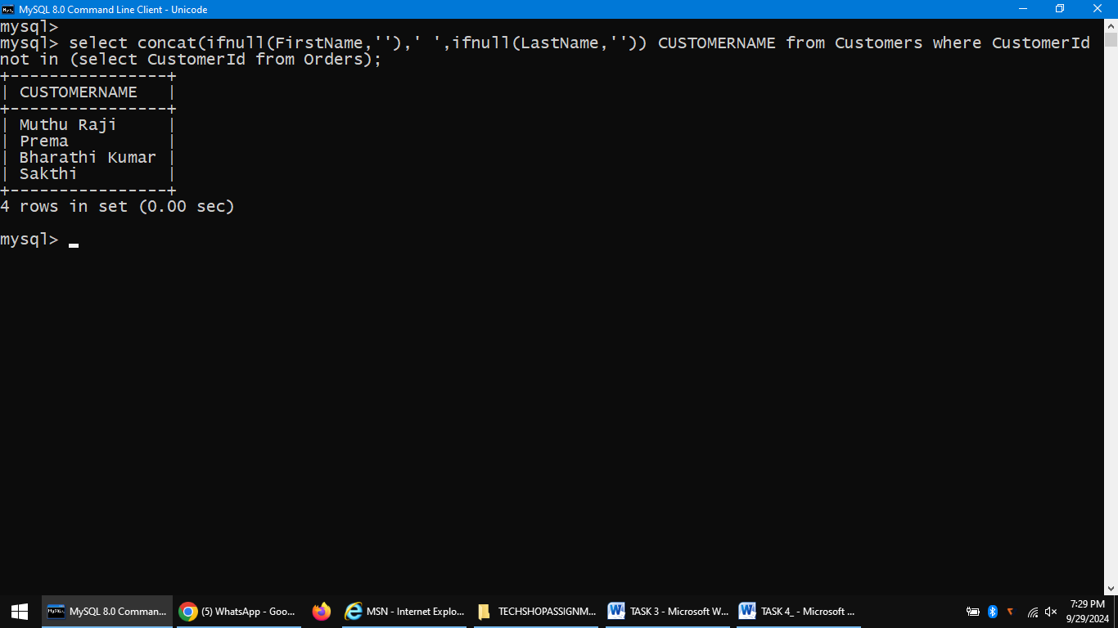

### 2. Write an SQL query to find the total number of products available for sale.

**select count(*) AvailableStock from Products where ProductId in (select ProductId from Inventory where QuantityInStock>0);**

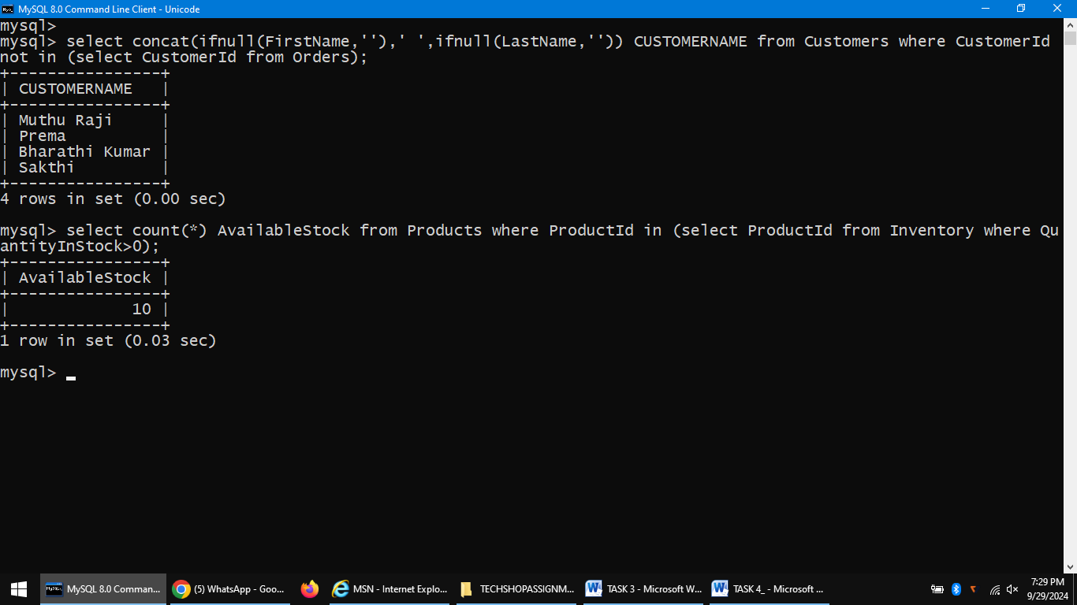

### 3. Write an SQL query to calculate the total revenue generated by TechShop.

**select sum(TotalAmount) TotalRevenue from Orders;**

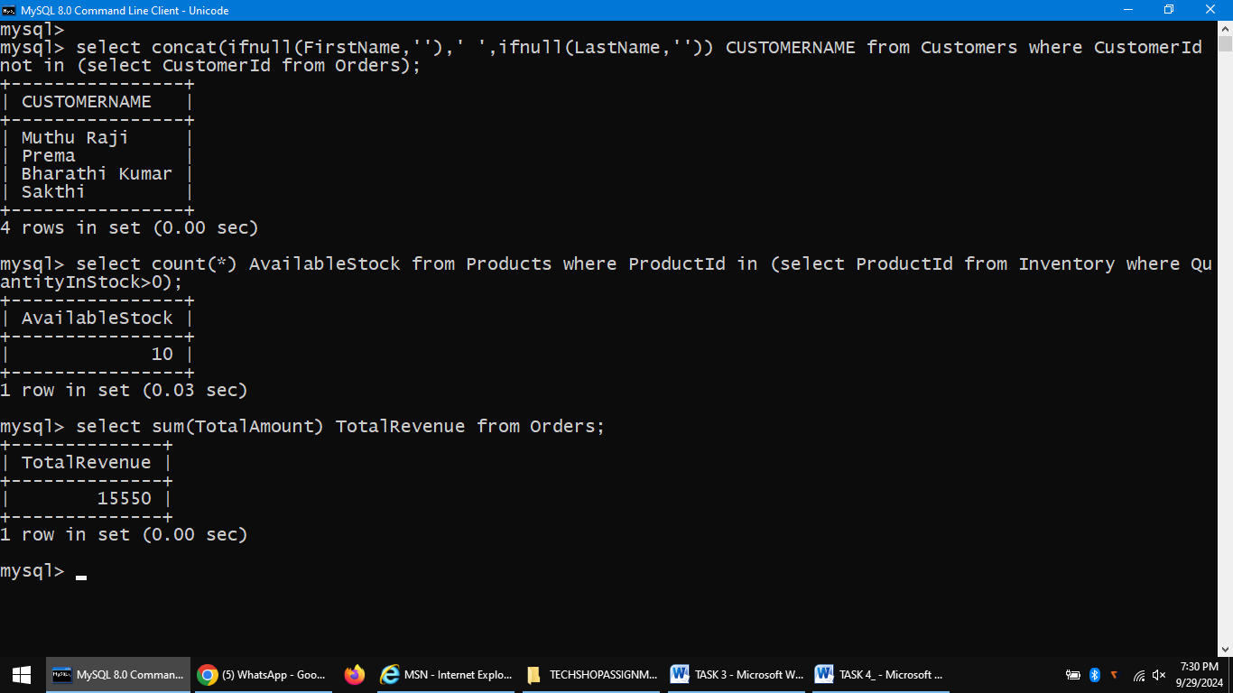

4. Write an SQL query to calculate the average quantity ordered for products in a specific category.

**SELECT AVG(od.Quantity) AS AverageQuantityOrdered FROM OrderDetails od**

**JOIN Products p ON od.ProductID = p.ProductID WHERE p.Category = 'Electronics';**

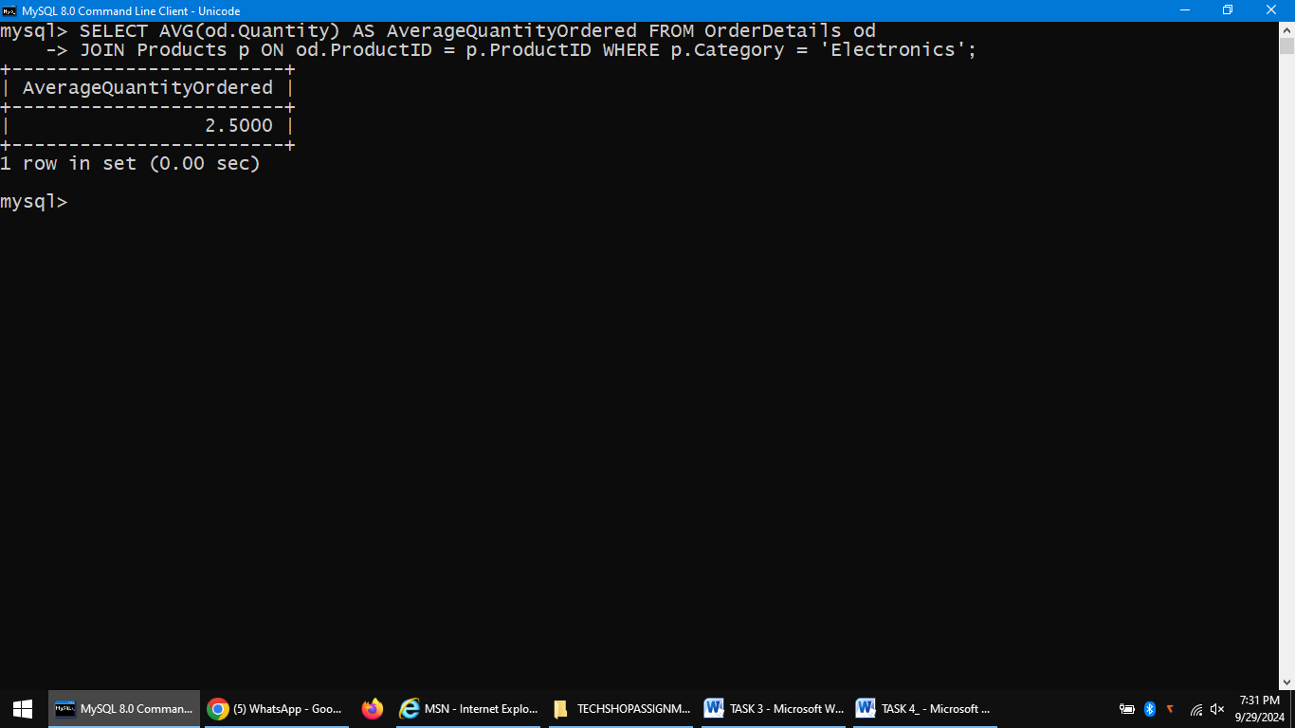

5. Write an SQL query to calculate the total revenue generated by a specific customer. Allow users to input the customer ID as a parameter.

**select sum(TotalAmount) TotalRevenue from Orders where CustomerId in (select CustomerId from Customers where FirstName='Raju');**

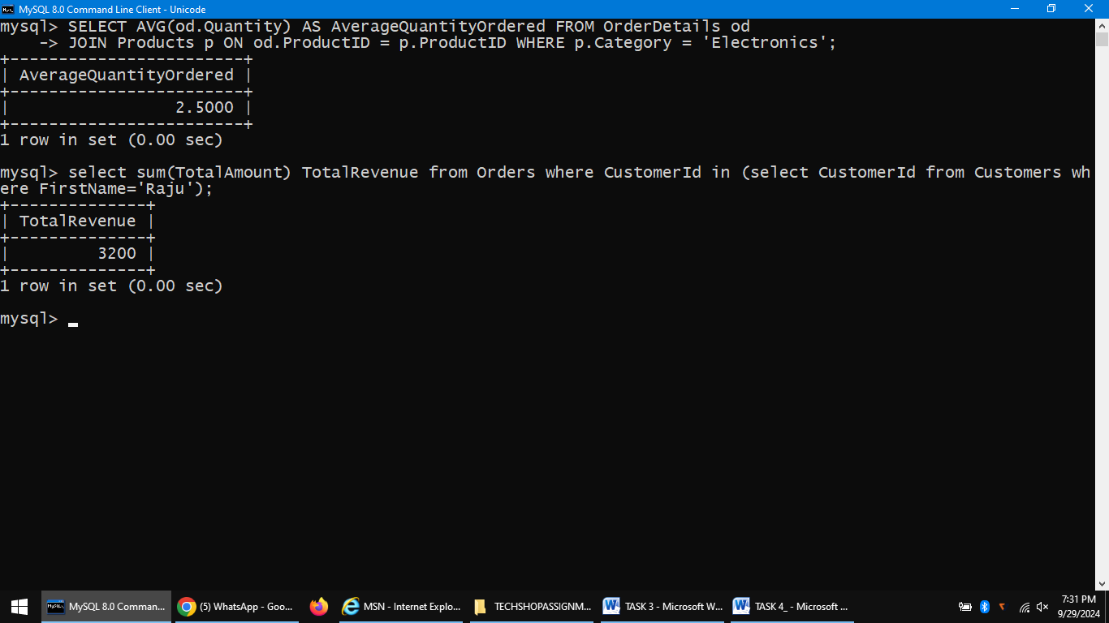

6. Write an SQL query to find the customers who have placed the most orders. List their names and the number of orders they've placed.

**SELECT concat(ifnull(FirstName,''),' ',ifnull(LastName,'')) CUSTOMERNAME, Order_Count FROM Customers JOIN (SELECT customerId, COUNT(orderId) AS Order_Count FROM Orders GROUP BY customerId**

**HAVING COUNT(orderId) = (SELECT MAX(order_count) FROM (SELECT COUNT(orderId) AS order_count FROM Orders GROUP BY customerId) AS order_counts)) AS max_orders ON Customers.CustomerId = max_orders.CustomerId;**

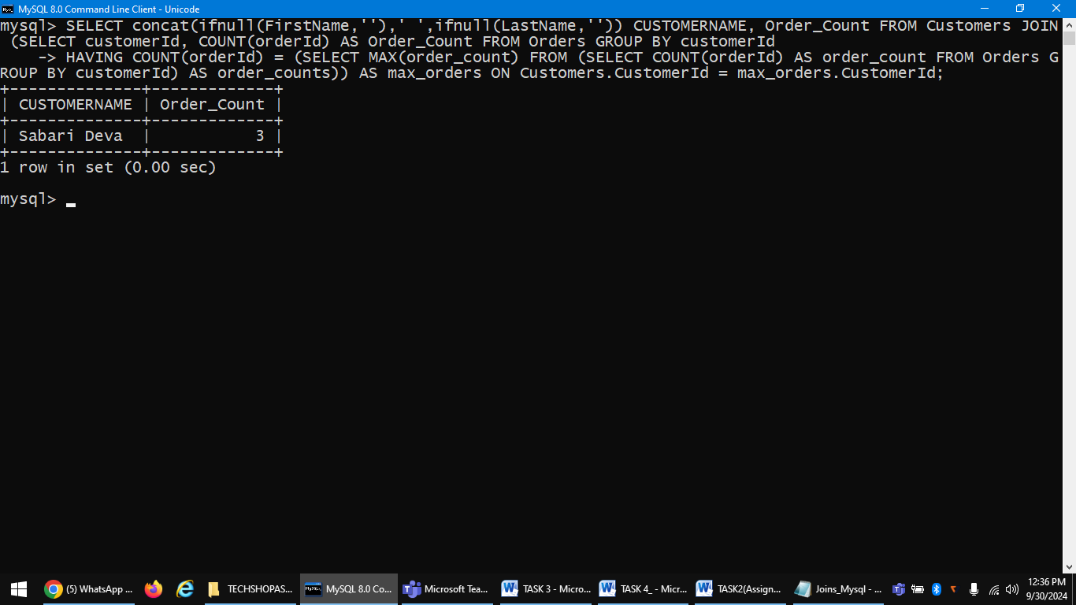

7. Write an SQL query to find the most popular product category, which is the one with the highest total quantity ordered across all orders.

**SELECT p.Category, SUM(o.Quantity) AS total_quantity_ordered FROM Products p JOIN OrderDetails o ON p.ProductID = o.ProductID GROUP BY p.Category ORDER BY total_quantity_ordered DESC LIMIT 1;**

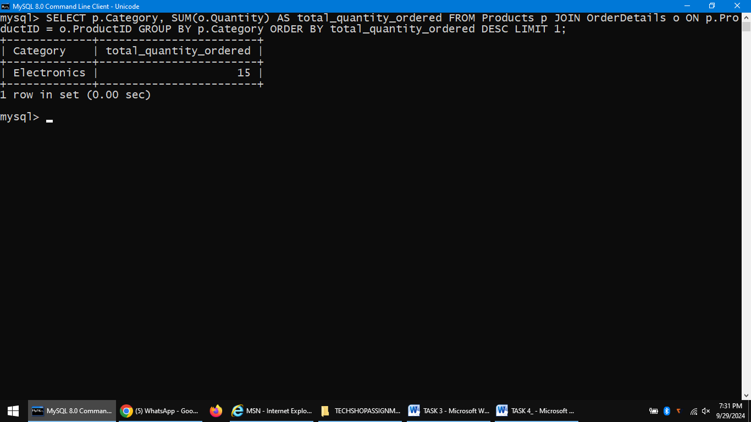

8. Write an SQL query to find the customer who has spent the most money (highest total revenue) on electronic gadgets. List their name and total spending.

**SELECT c.FirstName, customer_spend.Total_spend FROM Customers c JOIN (SELECT o.CustomerId, SUM(o.TotalAmount) AS Total_spend FROM Orders o JOIN OrderDetails od ON o.OrderID = od.OrderID WHERE od.ProductID IN (SELECT p.ProductID FROM Products p WHERE p.Category = 'Electronics')GROUP BY o.CustomerId ) AS customer_spend ON c.CustomerId = customer_spend.CustomerId ORDER BY customer_spend.Total_spend DESC LIMIT 1;**

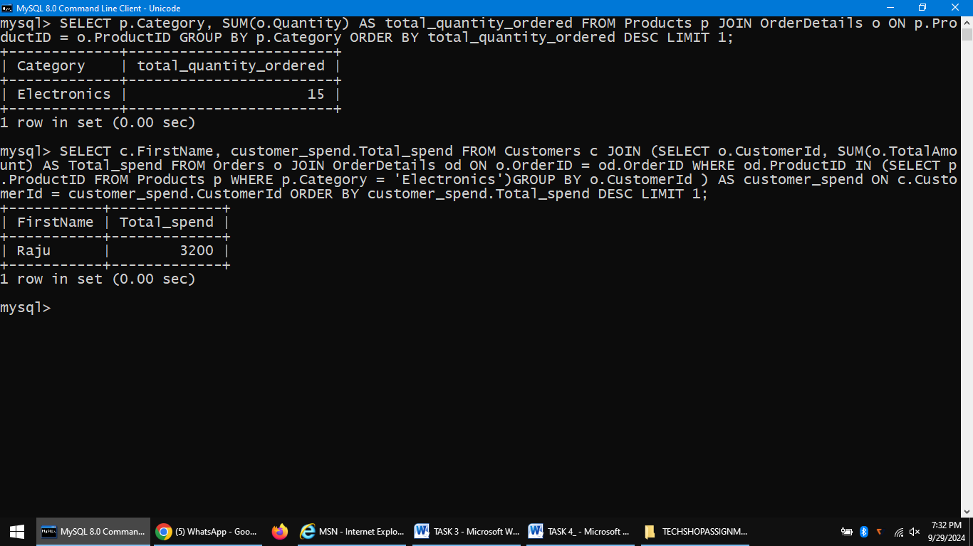

9. Write an SQL query to calculate the average order value (total revenue divided by the number of Orders) for all customers.

**SELECT concat(ifnull(FirstName,''),' ',ifnull(LastName,'')) CUSTOMERNAME,SUM(o.TotalAmount) / NULLIF(COUNT(o.OrderID),0)**

**AS AverageOrderValue FROM Customers c LEFT JOIN Orders o ON c.CustomerId = o.CustomerId GROUP BY c.CustomerId;**

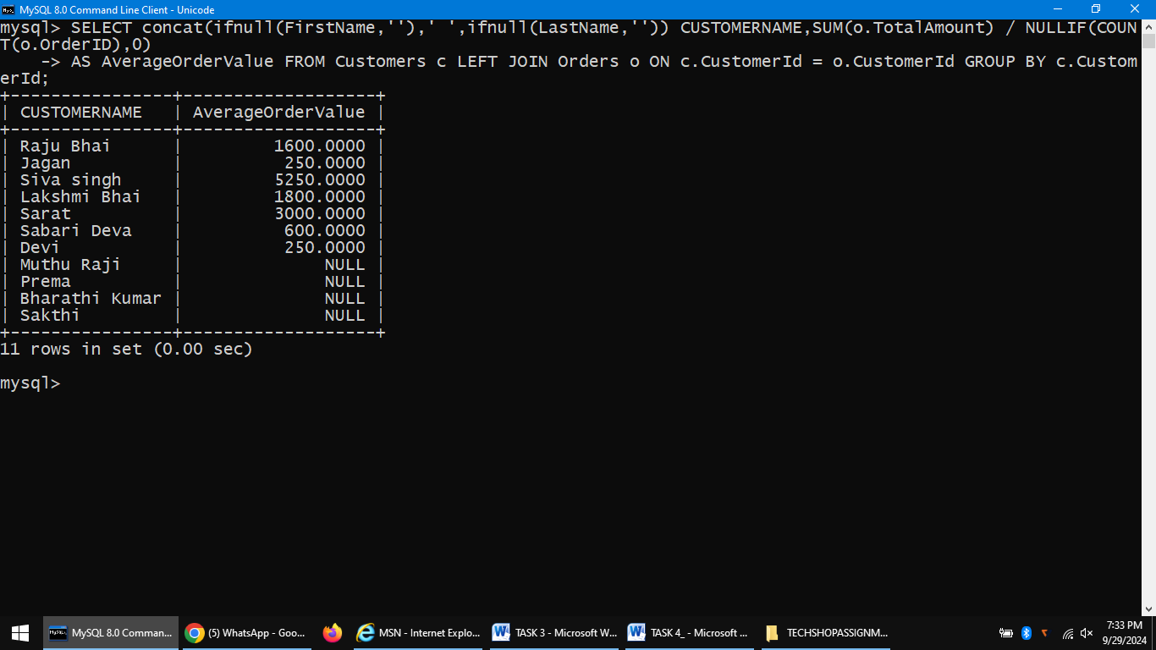

10. Write an SQL query to find the total number of orders placed by each customer and list their names along with the order count.

**SELECT concat(ifnull(FirstName,''),' ',ifnull(LastName,'')) CUSTOMERNAME, COUNT(o.OrderID) AS TotalOrders FROM Customers c LEFT JOIN Orders o ON c.CustomerId = o.CustomerId GROUP BY c.CustomerId;**

